SQL Script Files

Implementation

in .devcontainer / Docker Container

Table of Content

How to implement the SQL script files? 2

Step 1: Import the SQL script file into database / mysql directory 2

Step 2: Run commands in Docker container 3

Step 3: Close VS Code and re-open to run the application 3

How to Access SQL Database in Docker Container and Check Table Datas 3

# How to implement the SQL script files?

To implement any db script file into the .devcontainer / Docker container, ensure you import the sql file into the correct directory, and add the running command into the populate_db.sh file.

## Step 1: Import the SQL script file into database / mysql directory

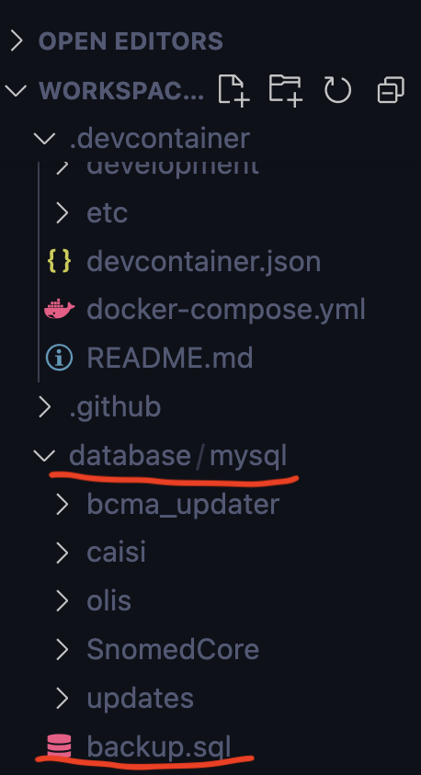

The backup.sql (as example) is the script file that needs to be implemented, ensure it is imported to the database / mysql directory.

## Step 2: Run commands in Docker container

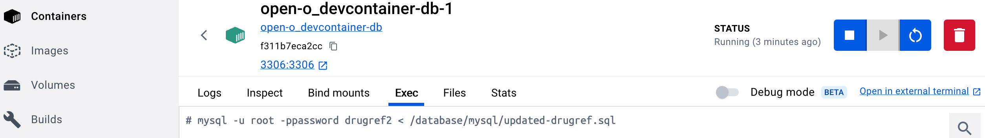The example above is for running updated-drugref.sql.  
Ensure the directory and the script file name in the running command is correct.

## Step 3: Close VS Code and re-open to run the application

Run this command in the VS Code terminal: make clean install.  
The container will automatically re-start in Docker with the new db script.

# How to Access SQL Database in Docker Container and Check Table Datas

Run command: mysql –u root –ppassword oscar (access the db)

Run command show tables; (all the tables in the db will display)

Run command select * from table_name; (the table and its data will display)

Run command SET FOREIGN_KEY_CHECKS = 0; (if you want to clear any table, to avoid the foreign key in the table restricts the truncate action, run the command first)